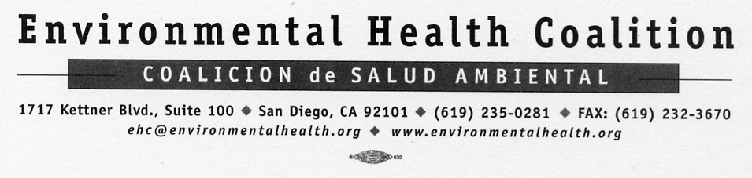

Media Release
For Immediate Release: Contact:
October 25, 2004 Leticia Ayala
(619) 235-0281
(619) 952-3632 Cell

Gabriel Fabila
(619) 235-0281
(619) 952-3358 Cell

Tainted Candy Proves to be Scarier than Ghost and Ghouls
National Lead Poisoning Prevention Week, October 24 through 30
EHC Urges Parents to avoid Lead Contaminated Candies

The National Lead Poisoning Prevention Week was established by the U.S. Department of Health and Human Services and is observed during the fourth week in October. This coincides with the Halloween celebration. But lately, the candy treats for Halloween have proved to be scarier than ghosts. .

More than 112 brands of candy sold in California, most of them from Mexico, have tested positive for dangerous levels of lead in the past decade and nothing has been done about it. In nearly every case, the candy — mostly marketed to Latino kids — is currently on store shelves and no action is being taken to protect children’s health. “Children are eating poison,” said Leticia Ayala, Director of the Environmental Health Coalition’s (EHC) Campaign to Eliminate Childhood Lead Poisoning. Imported Mexican candies contaminated with lead have been linked to 15 percent of the cases of childhood lead poisoning reported to state health department officials between May 2001 and January 2002.

Similar to ghosts, lead is invisible to the eye. “Our children are eating these poisons without knowing it and unfortunately our health department is not doing anything about it.” That’s why EHC is calling on all parents to avoid purchasing these candies during this Halloween season. In the coming weeks as parents prepare for Halloween EHC is urging consumers to protect their children and NOT BUY these candies. EHC is asking consumers to call in to the Toxic Treats Hotline at (619) 235-0281 with the name and address of stores selling these candies. The attached table can be found at www.environmentalhealth.org along with more information on the subject. The community at large is encouraged to call EHC with any questions regarding these candies or, for that matter, lead poisoning. EHC is not a poison control center; please call 911 with any emergency.

EHC has been at the forefront of uncovering this appalling problem. In 2001, EHC's community promotoras collected candies from a variety of local stores in San Diego and sent them to the California Office of Environmental Health Hazard Assessment (OEHHA). OEHHA worked with the Department of Health Services (DHS) to have the products tested by an independent laboratory. In July 2002, DHS released the results, showing that the average level was .77 ppm, with a high of 1.4 ppm. Current law does not require the Department of Health Services to issue a health advisory or require removal of lead-tainted candies.
- more -

Halloween Toxic Treats
Page 2 of 2

“These candies present an unacceptable health risk to children and should be removed from store shelves immediately before more children suffer the effects of lead poisoning,” again Leticia Ayala “We are working with parents and merchants to make sure they are warned of the dangers these products present. It's better to prevent than regret."

The state has estimated that as many as 15% of lead poisoned children in the state have eaten leaded candy. According to records in Orange County, candy was suspected as a source of lead poisoning nearly as often as paint. Statewide 75% of lead-poisonings are Latino children.

Some of Mexico’s biggest candy makers have had repeated high lead tests (see attached table). One candy, Lucas Limon, tested high seven times out of seven tests in federal labs and as a result, the manufacturer provided for a voluntary recall. However, Lucas Limon remains in many stores across the Southern California region. Chaca Chaca was found in three tests to contain three times the allowable lead level, and Tablarindo candy was found to contain more than five times the allowable level. The state issued a warning for Chaca Chaca candy because of its high lead content and it has been removed from the shelves. “We hope all of the tainted candy follows the fate of Chaca Chaca and we don’t need to warn parents again next Halloween.” Ayala said.

Lead poisoning is still the number one environmental health threat to children under the age of six. Most children are poisoned through chronic, low-level exposures, which can cause many developmental problems including reduced IQ, hyperactivity, impaired growth, learning disabilities, and behavior problems. Many children in San Diego’s low-income communities and communities of color are at high risk for childhood lead poisoning from other sources in their neighborhood, including deteriorating lead paint found on many of the homes in which they live.

###
EHC staff is available for interviews. Please call 619-235-0281 ext. 105 to schedule.

Mission Statement: Environmental Health Coalition is dedicated to environmental and social justice. We believe that justice is achieved when empowered communities act together to make social change. We organize and advocate to protect public health and the environment threatened by toxic pollution. EHC supports efforts that crate a just society and that foster a healthy and sustainable quality of life.

