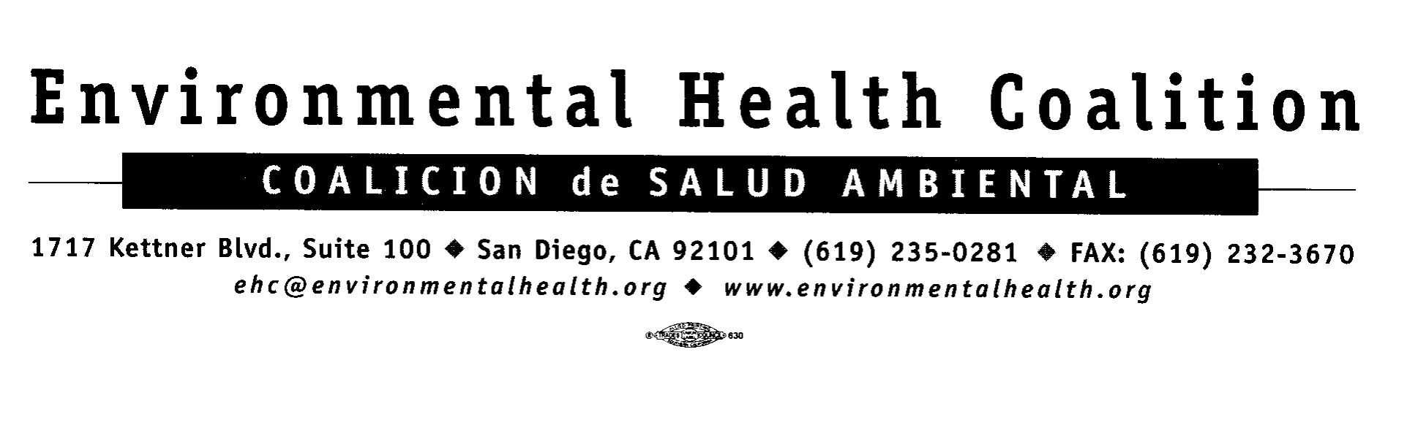
FOR IMMEDIATE RELEASE Contact: Christopher Leo
May 21, 2004 Phone: (714) 285-0355

EHC Contact: Leticia Ayala
Mobile: (619) 253-1359

Assemblymember Lou Correa calls for an investigation on lead content in candies from Mexico and why consumers are not notified of the lead levels

Santa Ana - Assemblymember Lou Correa (D-Santa Ana), chair of the Assembly Business and Professions Committee, has called for an investigation into why consumers did not know about the high content of lead in certain candies made in Mexico as well as what can be done to prevent this type of lapse in the future. The investigation request is based on a series of articles that began running in the Orange County Register on Sunday April 25.

Assemblymember Correa has called a meeting on this issue in Orange County for May 21st beginning at 1:30pm. The meeting will be held at the Rancho Santiago Community College District Administration Building in the Boardroom, 2323 North Broadway, Santa Ana. The meeting will include Assemblymember Juan Vargas, health officials and an opportunity for public comment.

Leticia Ayala, Director of Environmental Health Coalition’s Campaign to Eliminate Childhood Lead Poisoning, will present Assembly Bill 2297, a bill that would protect children from lead in candy.

Some of Mexico’s biggest candy makers - with brand names such as Montes Tomy, Limon 7 and Pico Diana - have had repeated high lead tests. One candy, Lucas Limon, tested high seven times out of seven tests in federal labs. Recently, the state issued a warning for Chaca Chaca candy because of its high lead content.

A leader on this issue has been Assemblymember Juan Vargas (D- San Diego). “When I discovered that a product so readily consumed by children was contaminated by high levels of lead, I immediately introduced legislation to bring awareness to the public. The state should take the lead in protecting our children against this hidden danger by assuming responsibility in testing and monitoring the lead content of candy and establishing a protocol to issue health warnings to the public. Not just sometimes, but every time, ” Vargas said.

Last year, Assemblymember Vargas introduced legislation on this matter, which was subsequently changed. Mr. Vargas is back this year with a similar bill, Assembly Bill 2297.

“Unfortunately in my assembly district, many of these candies are sold. We need to examine the issue and figure out if the state can do more to insure the public knows what is in these candies and how best to get that information out,” Vargas said.

####

