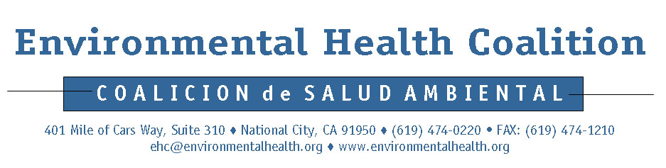
Media RELEASE

For Immediate Release: Contacts:
September 7, 2006 Laura Benson: (619) 474-0220 ext.107
Mobile: (619) 518-4913
Maria Moya (Español): (619) 474-0220 ext. 122
Mobile: (619) 993-6716

BARRIO LOGAN AT A CROSSROADS

RESIDENTS WANT AFFORDABLE HOUSING AND
A SUPERMERCADO AT MERCADO PROJECT SITE

The long-delayed Mercado Project will be the subject of a public meeting tonight at 5:30 PM at Calvary Baptist Church, 719 Cesar Chavez Parkway in Barrio Logan. Environmental Health Coalition (EHC) members will attend the meeting to demand that the Mercado project serve the current community’s needs and vision for its future. Specifically, it must provide deeply affordable housing for current residents and a neighborhood-serving grocery store.

The city’s affordable housing crisis is at its worst in Barrio Logan. While market-rate rents and home prices in Barrio Logan have traditionally been lower than elsewhere, many households have seen their rents double and triple in recent years under pressure from downtown luxury developments. In actuality, only 20% of Barrio Logan’s housing units are restricted to affordable rents but as many as 92% of residents need affordable housing.

EHC leader Blanca Romero, a resident of the neighborhood for 18 years, understands the importance of the Mercado Project focus, “The decisions made about the Mercado Project represent a crucial turning point for the community of Barrio Logan: will it thrive or will it be gentrified? If the City chooses to respect and support the community residents, their choice is clear.”

Romero worked with EHC leaders and staff during the last few weeks to survey 162 Barrio Logan residents about their preferences for the Mercado Project. 85% selected either affordable housing or a grocery store as their first priority for development. Only 2% stated that for-sale market-rate housing would be their priority.

EHC has long recognized the need for a community plan update in order to comprehensively address the diverse challenges facing Barrio Logan and ensure that the neighborhood will thrive. Drawn up in 1978, the current plan’s misguided zoning legitimized the incompatible mixing of polluting industries into a once fully residential neighborhood.
“EHC has worked with Barrio Logan residents for over two decades to rectify the injustices caused by poor land use planning. The Mercado Project represents a momentous opportunity to set the direction for the community planning process,” stated Maria Moya, EHC Lead Organizer. Councilmember Hueso has responded positively to the residents’ calls for a community plan and has committed to starting the process this year.

The city began the community plan update in 2003, but it stalled after about a year. Over the past two years, EHC carried on community-based planning efforts to create the Barrio Logan Vision, now endorsed by over 1000 residents, 28 businesses and 16 community organizations. The Vision calls for 1200 – 1600 new housing units that are recommended to meet the following criteria:

• Build all new units to be affordable according to the incomes of current residents.
• Restrict at least two thirds of new units for very low-income households or below (0-50% AMI).
• Build all new units as rental housing.

EHC Policy Advocate Laura Benson underscored the importance of designing the Mercado Project to address community-wide needs rather than as an isolated development project: “EHC’s housing vision for Barrio Logan would ultimately result in a diversification of housing types and income levels where, at bare minimum, 65% of units would be restricted affordable and 35% would be market rate. Because the Mercado project sits on publicly-owned land and has a high potential to attract subsidies and take advantage of other assistance programs, the opportunity to build deeply affordable units must be maximized.”

