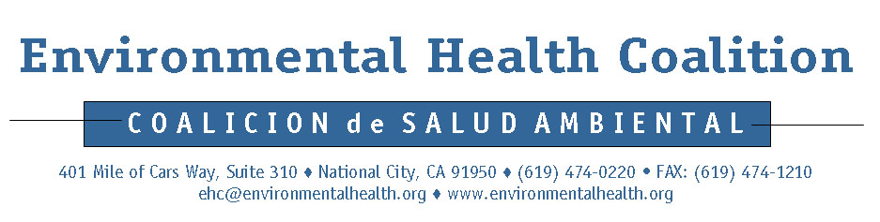
Media Release

For Immediate Release:  December 4, 2006 | Contacts:  Amelia Simpson: (619) 474-0220 ext 116  Mobile: (619) 952-5568  Magdalena Cerda (Español): (619) 474-0220 ext 117  Mobile: (619) 307-1695  Lourdes Luján: 011.52.664.647.7766

Mexican Government Funds Tijuana
Toxic Site Final Cleanup
Community’s Demands for Public Participation are Met

(December 4, 2006) – Tijuana, Mexico. Environmental Health Coalition (EHC) and its Tijuana affiliate, the Colectivo Chilpancingo Pro Justicia Ambiental, celebrated the announcement of a final plan and funding for the cleanup of the Metales y Derivados abandoned lead smelter. “We are proud that the Metales y Derivados Working Group was successful at building a respectful and honest working relationship to achieve this important step,” declared Magdalena Cerda, organizer for EHC’s Border Environmental Justice Campaign. “We believe that this unique model of transparency and collaboration can inspire other communities in their efforts to improve public health and the environment.” The working group members included the Colectivo, EHC, and government officials from Mexico and the U.S.

The cleanup plan calls for the excavation of a pit on the site, where 15,400 cubic meters of contaminated waste mixed with concrete will be contained in a lined cell. “While leaving the toxic waste on-site in a stabilized cell is not the best or most just solution, reaching consensus on a final remediation plan is an important step forward and represents a historic moment for my community, for the environment, for our crossborder region, and for Mexico,” said Lourdes Luján, a member of the Colectivo.

Although the community wanted the removal of all contaminants, they approved the proposal with several conditions, including the following:

- implementation of a Community Health and Safety Plan to inform residents of the cleanup process and respond to questions and complaints;
- resources for a third party representative of the community to oversee the process;
- placing 10 – 25 centimeters of clean soil over all areas of the site after the cell is sealed; and
- long term monitoring

“The success of the project will depend on its proper execution and future vigilance in monitoring,” said Enrique Medina, President of Alliance Consulting International and longtime consultant for the Colectivo and EHC on the Metales y Derivados case. “Since many things can go wrong with this kind of cleanup, we’re calling for a series of stringent oversight and monitoring procedures to be sure that this remediation is done right and the community is protected from contamination during the process and for many years to come.”

BACKGROUND

Mexico’s environmental minister made cleanup of Metales y Derivados a top priority in June 2004, when members of the Colectivo members and Mexican government officials signed a landmark agreement calling for a four-stage remediation to be completed within 5 years. $750,000 has been spent to date to remove 1,976 tons of toxics from the surface of the site. Fifty soil samples taken in September 2005 showed concentrations of lead as high as 200,000 mg/kg. 800 mg/kg is the industrial cleanup level in both Mexico and the U.S.

José Kahn, the owner of the San Diego-based New Frontier corporation, parent company of the Metales y Derivados battery recycler, abandoned the site in 1994 after a warrant was issued for his arrest for allegedly violating Mexican environmental law. The mixed hazardous waste left behind included 7,000 metric tons of lead slag. A 1998 petition filed with the environmental oversight commission of the North American Free Trade Agreement (NAFTA) by EHC and Colonia Chilpancingo prompted a report released in February 2002 validating community health concerns about the toxic contamination from Metales y Derivados. Independent analysis by experts cited in the report confirmed the need for urgent action to halt adverse health effects on people living or working in proximity to the hazardous site. No cleanup of the site resulted, however, since the NAFTA commission has no enforcement mechanism.

“Metales y Derivados is exhibit A for the failure of NAFTA to protect public health and the environment,” said Amelia Simpson, Director of EHC’s Border Environmental Justice Campaign. “NAFTA encourages industries to operate in Mexico, without creating any enforcement mechanism to compel those industries that pollute to clean up their toxic waste. The NAFTA model of so-called free trade must be replaced by fair trade that includes enforceable environmental mechanisms.”

###

