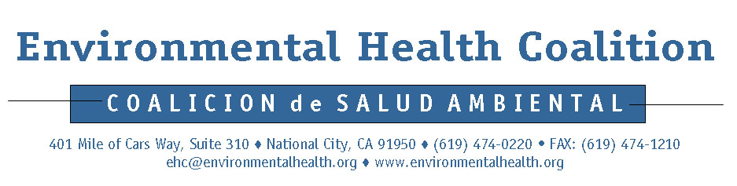
Media Release

For Immediate Release: Contacts:
September 5, 2006 Laura Hunter: (619) 474-0220 ext. 102
Mobile: (619) 997-9983
Georgette Gomez (Español): (619) 474-0220 ext. 104
Mobile: (619) 952-4589
Leiana Naholowaa: (619) 474-0220 ext. 101
Mobile: (619) 993-6743

Warning – Fish From San Diego Bay May Harm Your Health!
Coalition Gathers to Raise Awareness of Warning Signs

(September 5, 2006) – Pepper Park Public Fishing Pier, National City. Today, State Senator Denise Ducheny was joined by representatives of the Environmental Health Coalition, San Diego Coastkeeper, local fishermen, and members of a variety of community and health organizations and volunteers to announce the posting of new fish consumption warning signs on San Diego Bay.

Now written in English, Spanish, Tagalog and Vietnamese, the County Department of Health Services and the San Diego Unified Port District provide more specific advice in the signs to fishers of the Bay compared to what was originally posted in 1990.

“Installing these signs will help notify bay visitors of the mercury, PCBs, and other chemicals that have been found in the Bay’s fish,” stated Senator Ducheny, “which may have serious health impacts to pregnant women, children, and frequent consumers of fish.”

Laura Hunter, Director of EHC’s Clean Bay Campaign, expressed support for the updating and installing of the new warning signs: “What you don’t know, can hurt you. We thank the Port and the County for taking steps to protect human health. These signs are important at the public fishing piers because many frequent fishers of the Bay are from low-income communities of color and are at high risk of health impacts from eating Bay fish.”

According to the 2005 Pier Fishers Survey results conducted by the Environmental Health Coalition, of the 109 fishers surveyed:
- 96% were Latino or Filipino
- Over half fished at least once a week
- Almost two-thirds of the fishers eat the fish they catch
Georgette Gomez, EHC Community Organizer, stated, “Independent studies that have been done on the potential health risks of eating fish from San Diego Bay all state that frequent consumers of fish could face potential health risks. These signs will give fishers the information they need.”
Michael Nguyen, a volunteer with EHC, translated the signs into Vietnamese. He stated that “people from a Vietnamese cultural background can be especially at risk due to reliance on fishing as a subsistence food source for their families, so this is important information for them to know.”

Years of military and industrial activities have contaminated the sediments in San Diego Bay which poses significant risks to frequent consumers of Bay fish. Some of the most toxic sediments, those in the NASSCO and Southwest Marine Shipyard leaseholds, have not been cleaned up. In fact, the shipyards are fighting cleanup actions.

The responsible agency for directing cleanup of toxic sediments in San Diego Bay is the San Diego Regional Water Quality Control Board. The original request for NASSCO and Southwest marine to investigate their toxic sediment problems was issued in 1991 and to date, no cleanup action has been taken at the shipyards.

Key cleanup decisions will be made in the next year and yet, there are two vacancies on the Regional Water Quality Board. Environmental Health Coalition, San Diego Coastkeeper, and other member organizations of the San Diego Bay Council are calling on the governor to fill two vacancies with individuals who have a demonstrated commitment to protection of human health and environmental justice.

"The health and safety of our bays and beaches is of the utmost importance to our region,” stated Senator Ducheny, “These and other common sense actions to improve our water quality are a reflection of the leadership of Jack Minan, Chairman of the San Diego Regional Water Quality Control Board and that is why I have joined the members of the Bay Council in urging the Governor to reappoint Chairman Minan and appoint two candidates with a demonstrated commitment to public health and environmental justice to the two open seats of the Board.”

Dan McKirnan, EHC Boardmember and founder of the Clean Bay Campaign stated, “I remember clearly when these first sign were posted 16years ago. I look forward to the date then they will come down because they are no longer needed. If we do our job and clean up San Diego Bay, that day will come soon.”

Warning sign in English:  WARNING!  Fish From The Bay May Contain Chemicals  Believed To Cause Cancer and Birth Defects  Per Month, Do Not Eat More Than  Adults – 2 Meals  Pregnant Women – 1 Meal  Children Under 6 – None  Avoid Eating Stingray, Sand bass, Croaker  and Shellfish.  For More Information, Please Call The County of  San Diego, Department of Environmental  Health Services — (800) 253-9933 | San Diego Bay Council member organizations include:  Environmental Health Coalition  San Diego Coastkeeper  Sierra Club, San Diego Chapter  Surfrider Foundation, San Diego Chapter  San Diego Audubon Society

