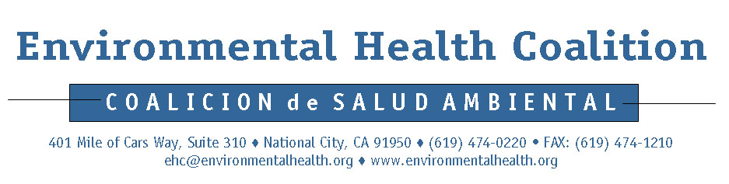

Media Release

For Immediate Release

Contacts:

Diane Takvorian: (619)474-0220, x112, cell (619)992-0805
Spanish: Georgette Gómez: (619)474-0220, x104, cell (619)952 4589

EHC Unveils “Vote NO on Prop 98” Billboard
Broad coalition comes together to expose proposition’s hidden agenda

(May 28, 2008) – National City, CA. Standing in front of a replica of the EHC No on 98 billboard, EHC was joined by representatives from labor, affordable housing and water supply to voice their opposition to Prop 98. The billboard is located on Harbor Drive and is viewed by about 9,000 drivers each day.

“Prop 98 will have a huge negative impact on our lives every single day,” said Diane Takvorian, EHC’s Executive Director. “We want to make certain every voter knows the truth about Prop 98 – it does not reform eminent domain, as its supporters claim, but removes nearly all local government authority to protect our environment, create appropriate zoning and develop our communities in a manner that serves everyone.”

Opposition to Prop 98 comes from almost every sector. In addition to Takvorian, speakers at the media conference included Lorena Gonzalez, Secretary-Treasurer, San Diego-Imperial Counties Labor Council; Tom Scott, Executive Director of San Diego Housing Federation, and Dennis Cushman, Assistant General Manager of San Diego County Water Authority.

Community members take to the street to get the word out

Prop 98 would make it illegal to ensure that homes and schools are located away from sources of pollution, like industries. “This proposition guts environmental protection and local planning, and could eliminate key provisions of the Old Town National City Specific Plan which works to improve air quality and health,” said Georgette Gómez, EHC Voter Project Coordinator.

EHC has been actively involving community leaders in the electoral process for the last few months with canvassing efforts in National City neighborhoods, serving to increase voter turnout at the polls.

“Going door to door and talking to registered voters in National City is very important because many people are not informed about the propositions and we can inform them on the issues that will greatly affect their lives.” said Alejandra Jaramillo, EHC Community Leader.

See attached sheet for quotes from Press Conference Speakers

Quotes From Other Press Conference Speakers

"The San Diego Housing Federation opposes this deceptive proposition that will make housing in California even less affordable by taking away renter and mobile home owner protections, essentially requiring low income families to pay higher rents or become homeless. Furthermore, it will make the development of affordable housing even more expensive because of the threat of frivolous law suits claiming that an affordable apartment complex will lower housing values in the neighborhood (a fact that is unfounded but is widely held belief),"said Tom Scott, Executive Director of the San Diego Housing Federation.

"Prop 98 is extremely dangerous to working families because it forbids communities from making important laws that protect both affordable housing and class size at our schools," San Diego-Imperial Counties Labor Council Secretary-Treasurer Lorena Gonzalez said. "That's why the 120,000 working families of the Labor Council are standing with our allies at the Environmental Health Coalition to oppose this very dangerous ballot initiative."

At its board of directors meeting on February 28, the San Diego County Water Authority adopted an oppose position on Prop. 98 because the measure could prevent public agencies such as the Water Authority from acquiring water supplies and land needed for environmental mitigation, water storage, pipelines and other essential water supply infrastructure projects.

“Prop. 98 would expressly prohibit the use of eminent domain to acquire property for the ‘consumption of natural resources’,” said Dennis Cushman, Assistant General Manager of the San Diego County Water Authority. “The Water Authority is building $3.6 billion worth of major regional infrastructure projects vital to sustaining our region’s $163 billion regional economy and the quality of life for more than 3 million people. Every one of these projects is intended for the ‘consumption of natural resources,’ specifically water. There is no more essential natural resource than water.”

