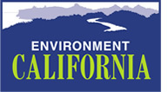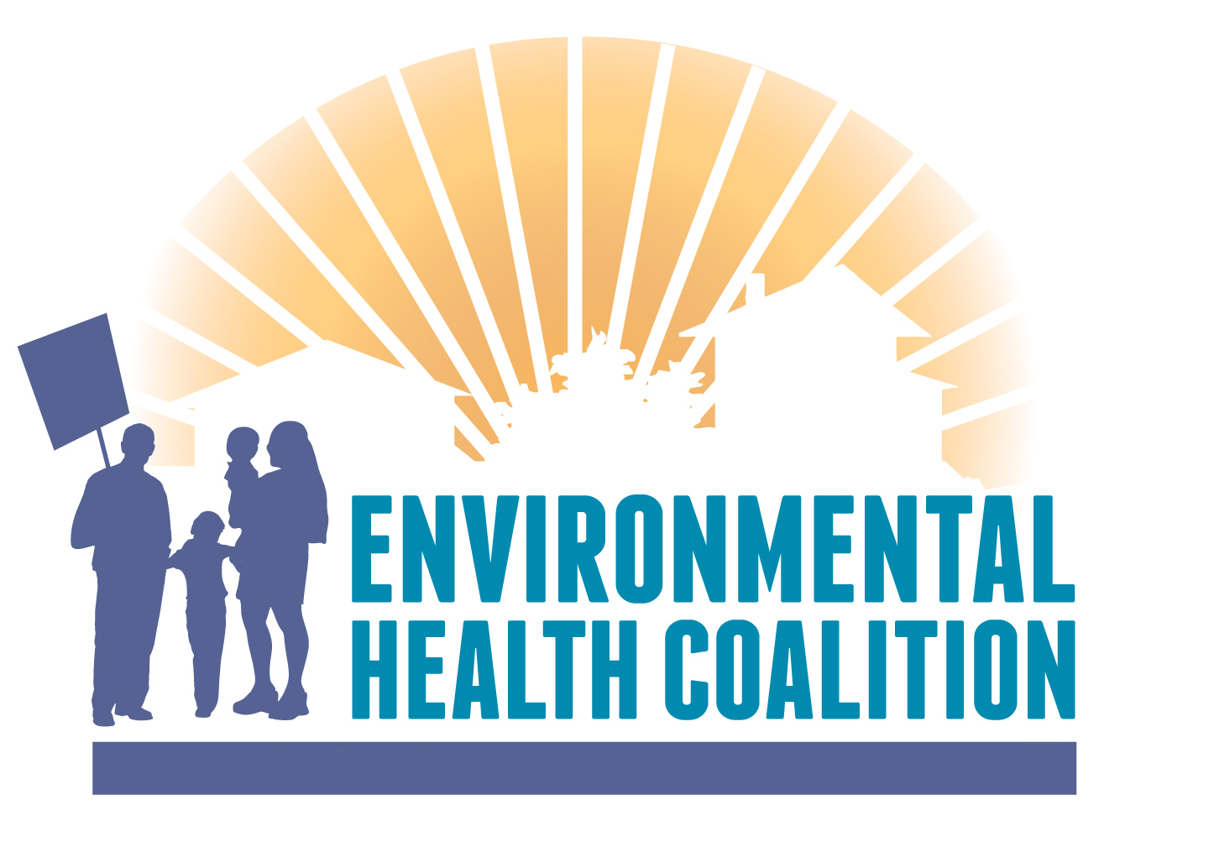

Media Release

For July 28, 2011 Contact: Bernadette Del Chiaro, Environment California
916-446-8062 x 103 (office); 916-765-3224(mobile)
Nicole Capretz, Environmental Health Coalition (619) 474-0220x105

NEW REPORT: Up to 15,000 Californians
Enrolled in Green Job Training Programs Annually
Investment, Expansion of Green Job Sector Key to Economic Recovery
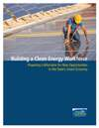
San Diego – On the heels of Governor Jerry Brown’s push to build 12,000 megawatts of solar and other forms of small-scale clean energy by 2020, environmental and green job advocates today highlighted the need to train the next generation of workers locally to help build California’s clean energy future.

According to a new report by Environment California Research & Policy Center, California’s ground-breaking clean energy and environmental policies are creating new job opportunities for Californians and the state’s educational institutions are stepping up to the plate to train the next generation of clean energy workers to build and operate California’s clean energy future.

“Job training programs are a critical engine for developing the workforce needed to achieve the state’s environmental goals,” said Bernadette Del Chiaro, director of clean energy programs at Environment California Research & Policy Center and co-author of the report. “Thousands of Californians are seeking refuge from the recession via the growing green energy economy.”

“The environment and the economy go hand in hand,” said San Diego City Council President Tony Young. “We need to invest in our future by expanding the local green job sector and training a new generation of San Diego workers to fulfill our vision of a clean energy future.”
The report, “Building a Clean Energy Workforce: Preparing Californians for New Opportunities in the State’s Green Economy” documents the nearly 300 green job training programs at over 130 institutions throughout the state with up to 15,000 students enrolled annually. According to the report, more than 500,000 employees currently work in “green jobs” in the state, and the energy efficiency sector is projected to employ two to four times as many workers in 2020 compared to 2008.

“Right now, the students and the teachers are out ahead of the policy makers who are driving the market for green jobs,” said Nicole Capretz, Green Energy/Green Jobs Campaign director for the Environmental Health Coalition, which works to promote the establishment of quality green jobs. “We need to rapidly expand the market for clean energy through strong policies so that we can put these tens of thousands of skilled workers to work.”

“Building a Clean Energy Workforce” was released at MAAC Project Training Center in Barrio Logan. The event highlighted the institution’s green jobs training program, which trains over two dozen students each year in green-oriented classes.

“The MAAC Project has trained underemployed and at-risk youth on green construction job skills to ensure the green economy lifts all boats,” said Craig Frederickson, Manager of Vocational Training Program at MAAC Project. “Today, the rapidly expanding clean energy sector is creating a whole new category of job opportunities for San Diegans and we are part of making sure everyone has a way to get in.”

As highlighted in the report, California’s strong clean energy policies (such as the 33% by 2020 renewable electricity standard signed into law by Governor Brown in April) have already benefited the state’s broader economy, energizing new growth in clean energy industries. Consider the following:
- Approximately 40 percent of global clean technology-oriented venture capital comes to California. Businesses and institutions in California have received $11.6 billion worth of clean technology venture capital funding since 2006.
- From 2007 to 2008, even as unemployment increased during the early stages of the economic downturn, employment in the green sector increased by 5 percent.

To ensure continued growth of the clean energy economy and to fulfill the promise of new job opportunities for those graduating from these green training programs, California must maintain its commitment to big, bold clean energy policies. Specifically California should establish a strong set of rules for cleaning up cars between 2017 and 2025, fully implementing policies needed to achieve Governor Brown’s vision of building 12 gigawatts of distributed energy resources (e.g. rooftop solar) by 2020 and subsequently moving beyond the state’s 33% renewable energy mandate by 2020.
###

